**QA Test Feedback**

**Date 5th July, 2024**

**Time: 10:05am**

**QA Tester: Gabriel, Kunmi**

**What worked (IOS on test flight)**

1. Sign up successfully – Passed
2. Email verification – Passed
3. Financial calculator workflow after Sign up – Passed
4. Onboarding workflow – Passed
5. I was able to validate my 7G assumptions – Passed
6. Portfolio: All the requirements were met – passed

**360 Items**

1. **Net worth**
   1. Add Home Equity
   2. Current Home Equity
   3. Current Pensions
   4. Current liability value
   5. Current asset value

*All requirements were met successfully –*Passed

1. **Liabilities**
   1. Account creation

*All requirements were met successfully –*Passed

1. Retirement
   1. Add Account

*All requirements were met successfully –*Passed

1. **Investment-** 
   1. Business asset
   2. Risk asset
   3. Appreciating asset
   4. Intellectual asset
   5. Depreciating asset

*All requirements were met successfully –*Passed

1. **Cash**
   1. Account Creation

*All requirements were met successfully –*Passed

1. **Mortgage**
   1. Account Creation

*All requirements were met successfully –*Passed

**Comment: There is a default account that was created on mortgage**

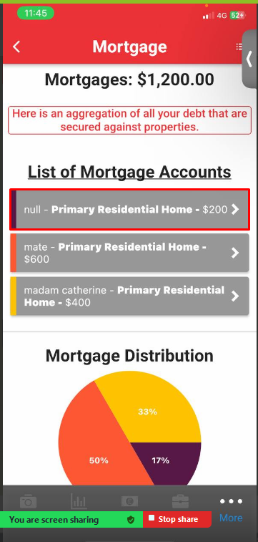

1. **Action plan**
   1. Business Asset
   2. Risk Asset
   3. Appreciating Asset
   4. Intellectual Asset

*All requirements were met successfully –*Passed

1. **Assets**
   1. Investments
   2. Cash
   3. Pension
   4. Home equity

*All requirements were met successfully –*Passed

1. **iLab clock**
   1. Current Position
   2. Edit target

*All requirements were met successfully –*Passed

1. **Expenditure**-
   1. Value of accommodation
   2. Value of transportation
   3. Value home and Family
   4. Value of debt repayment
   5. Value of Utilities

*All requirements were met successfully –*Passed

1. **Philanthropy**
   1. Giving
   2. Set budget

*All requirements were met successfully –*Passed

1. **Protection** 
   1. Add Account

*All requirements were met successfully –*Passed

1. Seed: All requirements were met successfully- passed
2. **Support**- *All requirements were met successfully –*Passed
3. **Feedback**- *All requirements were met successfully –*Passed
4. **Setting**: - *All requirements were met successfully –*Passed
5. Account created on web and tested on IOS *–*Passed
6. Account created on IOS tested on web *–*Passed
7. **Password**: *All requirements were met successfully –*Passed

**What did not pass**

* + - 1. App deep linking- **verdict did not Passed**
      2. **Protection**: We were unable to view document on account created on protection

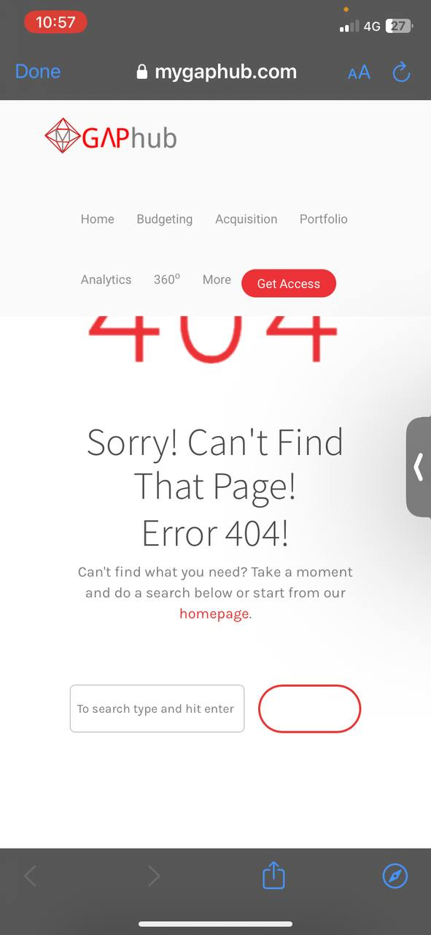

**Verdict: Did not pass**

* + - 1. **Home Equity**: mortgage accounts created are not coming up on home equity page.

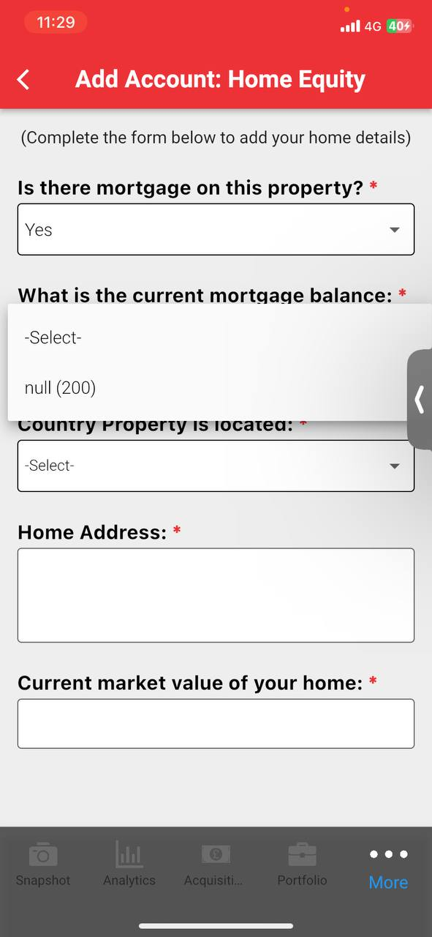

**Verdict: Did not pass**

* + - 1. **Acquisition:** We could not visit any of the **REAP**

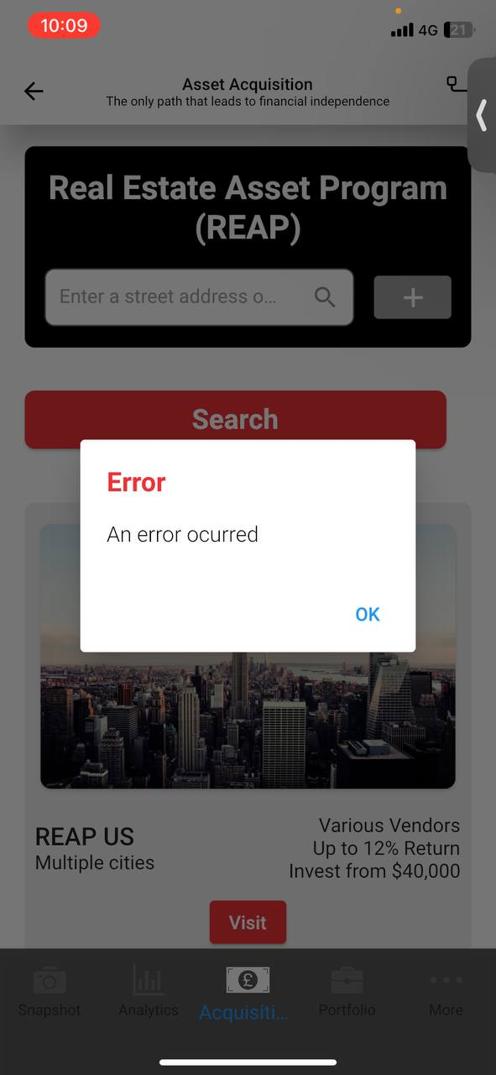

**Verdict: Did not pass**